Ārohia Trailblazer Grant
Application Form Example

This application form example is intended to give you visibility of what’s required for an Ārohia Trailblazer Grant application. Please read the information about the Ārohia Trailblazer Grant on the Callaghan Innovation website , and complete the self-assessment tool, before completing this application.

When you are ready to apply, log into the online portal (IMS). Please do not submit or upload this form. We recommend you use it to prepare your application, then copy and paste the information into the relevant sections in IMS.

IMPORTANT INFORMATION

Important Information

Important Information
- This is a contestable grant, which means only the best applicants from each application round will receive funding. We may decide NOT to award any grants in a particular round if no application is assessed as having sufficient merit.
- Given the contestable nature of the grant, and to ensure a level playing field, Callaghan Innovation staff and Regional Business Partner Navigators will be unable to assist you with your application.
- Once you have submitted your application, it cannot be amended for any reason. Please ensure you thoroughly read all requirements, check your work and submit your best application possible.
- Any costs in your Ārohia Trailblazer Grant Work Plan that are deemed ineligible will be removed and there will be no opportunity to revisit these costs. Please ensure you only insert eligible activities as per the guidance on our website.

Guide to completing this application
This application has six sections:

Section 1: Applicant Information
This section collects information we need to know about your business.

Section 2: Entity Eligibility Declarations
Here we ask you to declare that your business is eligible to apply for the Ārohia Trailblazer Grant.

Section 3: General Eligibility Declarations
Here we ask for other general declarations and further information that affect eligibility for the Ārohia Trailblazer Grant.

Section 4: Your Innovation
This is where we ask you about the core attributes needed for the grant, and for the information we need to assess your innovation.

Section 5: Ārohia Trailblazer Grant Work Plan & Costings
This is where we ask about the types and costs of activities you will carry out (using grant funding) if your application is successful.

Section 6: Financial information
Here we ask for financial information about your business that we need to support your application.

Spell check function:
We recommend that you use the spell check function across each question as applicable as it is not automatic. You can action this from the toolbar at the top of each text box.

SECTION 1: APPLICANT INFORMATION

1.1 Application Summary
Purpose of the Ārohia Trailblazer Grant

The Ārohia Trailblazer Grant can support successful applicants with the costs of eligible activities (excluding R&D) involved in taking to market an innovation that has potential benefits for Aotearoa New Zealand’s innovation ecosystem.
The Ārohia Trailblazer Grant does not fund R&D activities.

Investment area: | Ārohia Trailblazer Grant
Contracting  organisation: | The contracting organisation (‘business’) is legally responsible for signing the Ārohia Trailblazer Grant Funding Agreement, should this application be successful. Please check that the correct entity is shown below, as it can cause processing delays if applications are received under the wrong business name.  The address information shown below is not editable by the applicant. Please email fcmoperations@callaghaninnovation.govt.nz to advise of any changes.
 | [Read-only field – Pre-populated]
Postal and Courier addresses: | [Read-only field – Pre-populated]
New Zealand Business Number: | NZBNs are unique identifiers allocated to NZ businesses to make it easier for business to interact with government and with each other. Each NZBN is a 13-digit Global Location Number (GLN) provided by GS1 New Zealand.
 | [Read-only field – Pre-populated]
Total costs: | Enter your expected spend on eligible activities, as outlined in your Ārohia Trailblazer Grant Work Plan and Costings (Section 5.1). Note the minimum total cost is $333,334.
 | $ GST exclusive  Enter amount here | $ GST amount  [Pre-populated - Calc] | $ GST inclusive  [Pre-populated - Calc]
Innovation Project title: | Provide a brief title of your innovation project, in a way that's not commercially sensitive. Please note that if your application is approved, the following will become public information: grant title, innovation project title, your business name and the value of funding received.
 | Enter text here
Proposed Start and End Dates: | Enter the proposed start and end dates for the period during which you’ll be carrying out eligible activities using Ārohia Trailblazer Grant funding. The end date can’t be more than 24 months after the start date. The dates will be confirmed at time of contracting should your application be successful. They may differ from the dates recorded here, depending upon the approval date. Costs incurred prior to the start date and after the end date will be not claimable.
 | Start Date  [Enter date here] | End Date  [Enter date here]
Your Innovation - project description:

Provide a brief description (max 50 words) of your innovation project, in a way that’s not commercially sensitive. This information will be used:
- for reporting purposes, and
- to help us identify any potential conflicts of interest, should your application reach the stage where it’s assessed by the Grant Evaluation Panel.

Enter text here
Provide ANZSIC Industry Code that best matches your business:

ANZSIC is the Australian and New Zealand Standard Classification of Industries. These codes are published on the StatsNZ website. Select ‘Industry - ANZSIC06V1.0’ in the classification code finder.

Enter text here

1.2 Key Contacts
Provide details for the contact person.
The contact person is the person in your business we can discuss the Ārohia Trailblazer Grant application with, and who we will send all grant and contract related information to.
Information required: Name, business email address and phone number

Enter text here

1.3 Bank Account
Provide your business’s bank account information in the table below.
The bank account must be in the name of the applicant (same as the contracting organisation) as noted in section 1.1)

The bank account provided must be from a registered New Zealand bank and in the name of the applicant.

Bank account name | Account | Email address | Pay to account | Bank account name
Enter text here

Provide verification of the bank account information you have entered above:
This may be a scanned bank statement or screenshot from online banking. Check that the bank account name and detail can be clearly seen on the documentation provided.

Once you have selected your file to upload, click on SAVE (at the bottom of the screen), which will upload the document.

Upload document

1.4 Business Background
1.4.1 Provide a brief overview of your business, including its size, how long it has been in operation, and your core products, services and markets.

If you are a new business, tell us about your recent business activity.

Word limit 150 words.

Enter text here

SECTION 2: ENTITY ELIGIBILITY DECLARATION

2.1 Entity Eligibility
2.1.1 Confirm that your business is an eligible business entity:

To be eligible for an Ārohia Trailblazer Grant, you must be one of the following, tick one box from the list below:

*Control means 50% or more shares or voting interests in another entity, or control of appointments to an entity’s controlling board.
 | A Company registered (and incorporated) in New Zealand under the Companies Act 1993 that is not controlled* by the government or one or more government agencies
 | A Limited Partnership registered in New Zealand under the Limited Partnerships Act 2008 that is not controlled* by the government or one or more government agencies
 | a Māori Trust or incorporation under the Te Ture Whenua Māori Act 1993, or a similar organisation managing Māori assets under multiple ownership
 | A Company incorporated in another country but registered to do business in New Zealand (registered under the Overseas Register – ASIC or NON-ASIC)

2.1.2 Confirm that you are not an ineligible entity:

Ineligible entities include:
- Local authorities, Government departments or agencies
- State Owned Enterprises and Public Finance Act 1989 Schedule 4A companies
- Local, national and regional promotional bodies
- Crown entities
- Crown Research Institutes (CRIs)
- Tertiary Education Organisations (TEOs) including foreign-owned TEOs
- Entities controlled by any of the above
- Callaghan Innovation
- Sole traders
- Charitable trusts
- Partnerships
- Unincorporated Joint Ventures
- Unincorporated charities
- Incorporated societies
- Trusts (other than a Māori Trust as expressly stated under eligible criteria)

- Confirmed

2.1.3 If your business is a Māori Trust or a Māori statutory body, please identify the Act under which your business was established.

Enter text here
SECTION 3: GENERAL ELIGIBILITY DECLARATION

3.1 General Eligibility Declarations
The following declarations must be completed before we can assess your application for the Ārohia Trailblazer Grant.

3.1.1 Consent to share information

You consent to us disclosing information (including commercially sensitive and confidential information) to our employees and/or our professional advisors, auditors, service providers and independent contractors who have a specific need to have access to the information in the course of their work for us.
For example, we may use external assessors to assist us with assessing applications and our Grant Evaluation Panel will have access to your application. In each case, the information will be disclosed with a legal obligation to keep that information confidential and only used for the purpose for which it is disclosed.

Confirmed

3.1.2 Purpose of Ārohia Trailblazer Grant

You’re aware that the purpose of the Ārohia Trailblazer Grant is to support eligible activities involved in taking to market an innovation that has potential benefits for Aotearoa New Zealand's innovation ecosystem.

Confirmed

3.1.3 Non-R&D focus of Ārohia Trailblazer Grant

You’re aware that the Ārohia Trailblazer Grant does not support R&D activities.
.
Confirmed

3.1.4 Ārohia Trailblazer Grant 30/70 co-funding requirement

You’re aware that the Ārohia Trailblazer Grant can provide funding of up to $4 million on a co-funded basis, as follows:
- we can contribute 30% of up to $13.3 million of eligible costs, on the basis you will fund the other 70%
- based on the $13.3 million limit, the maximum we can contribute is $4 million
- you may choose to fund any costs over the $13.3 million limit yourself, but we can’t co-fund any amount above this limit
- you can have up to 6 months to obtain your 70% share of the co-funded amount, from the date we sign a Funding Agreement with you (provided you have a strategy in place to do this when you sign the agreement)
- your share of the co-funding doesn’t all need to be cash in the bank - it can include contractual agreements to provide payments over the period of the innovation project
- once a grant has been approved, we can’t increase the amount of funding we can provide
- the minimum grant funding is $100,000, therefore, $333,334 total costs must be incurred to be eligible.

Confirmed

3.1.5 Crossover with other government support

You're aware that:
- you can’t receive support from the Ārohia Trailblazer Grant for expenditure that is supported by other government initiative/s, and
- if this application is subject to audit in the future, you may be asked to provide evidence that no expenditure was supported by more than one government initiative.
.
Confirmed

3.1.6 Legal status and solvency

You declare that the business applying for this grant is:
- a legal entity capable of entering into a contract with Callaghan Innovation, and adhering to all obligations as set out in the Funding Agreement
- solvent and can pay its debts as they fall due.

Confirmed

3.1.7 Project, financial and risk management processes

You declare that your business will maintain appropriate project, financial and risk management processes regarding your innovation project, and if your application is successful, you agree that we may contact you periodically to discuss:
- the progress of your project, and
- any other matters relevant to our responsibilities as a funding provider.

 Confirmed

3.1.8 Not yet in-market

You declare that the product or service in your application is not yet for sale, or available to customers (not yet in-market) and you confirm you are aware that once your innovation is in market you are no longer eligible for funding.

You can find our full definition of “not yet in-market” on the Ārohia Resource Hub

Confirmed

3.2 Additional Information
3.2.1 Good character obligation
Are you aware of any issues (past, current or potential) relating to your business, its owners and directors (or equivalent), or your products and services that could bring the reputation of the Government, Callaghan Innovation or its grants programme into disrepute?

This should include any actual or pending legal action against your business, major shareholders or directors.

Callaghan Innovation must be satisfied that providing an Ārohia Trailblazer Grant to your business would not bring the reputation of Callaghan Innovation, the Grants Programme, the Government.

If you undertake actions, or we become aware during the course of the grant of actions which we deem likely to bring Callaghan Innovation, the Grants Programme or the Government into disrepute, we may choose to withdraw our support for your project.

Yes
No

If yes, outline the issues:
If no, please write “N/A” as your answer to this question.

Please keep it brief, bullet points preferred.

Enter text here

3.2.2 Conflicts of Interest
Are you aware of any potential conflicts of interest concerning your innovation project or business, or members of the Ārohia Trailblazer Grant Evaluation Panel?

Yes
No

If yes, please outline what these are:
If no, please write “N/A” as your answer to this question.

Max 50 words

Enter text here
3.2.3 Crossover with other government support
Have you received or applied for any other government support (other than equity support, e.g. NZGCP) for the innovation that is the subject of this application?

Yes
No

If yes, explain how you will ensure that you will not use different government support for the same activity.
If no, please write “N/A” as your answer to this question.

Enter text here
3.2.4 Does your innovation project involve using indigenous flora and fauna?

As a Crown Agency we are committed to upholding the Treaty of Waitangi partnership. It is recommended that engagement is made with Māori to discuss any commercialisation or other issues, related with using indigenous flora and fauna.

Yes
No

If yes, tell us about your engagement with local Iwi.
If no, please write “N/A” as your answer to this question.

Maximum 250 words, bullet points preferred.

Enter text here

SECTION 4: YOUR INNOVATION

Introduction to the Your Innovation Section
In the Your Innovation section we ask you questions to help us assess whether your innovation exhibits the attributes needed for the Ārohia Trailblazer Grant.

You should already be familiar with the sections covered, as they’re part of our self-selection tool and you should have spoken to a member of our team about whether you exhibit these attributes.

Novelty (Section 4.1)
- demonstrating that your product or service is truly new, unique, world-leading and ground breaking

Potential Benefits to the Innovation Ecosystem (Section 4.2)
- demonstrating that you’re creating something that helps other innovators in Aotearoa New Zealand to create new and unique products or services

Market Impact (Section 4.3), Commercial Feasibility (Section 4.4) and Commercial Viability (Section 4.5)
- demonstrating that your product or service is something customers want and will create a viable business

Refer to the Ārohia Trailblazer Grant Assessment Framework to understand how your application is assessed.

Supporting your written answers

Providing specific evidence
Successful applications provide robust evidence in support of the questions asked.

If you are uploading reports or slide decks please ensure these are four pages or less. To ensure fair, efficient assessment of applications, if you upload reports or slide decks that are more than four pages, we will not read past the fourth page.

Where to attach evidence, diagrams and images
If you’re providing copies of evidence, diagrams or images – ensure that these are converted into a document format that is supported by the online portal (word, excel or pdf) and upload this in the space provided in the relevant sections. Please do not paste diagrams or images into the text boxes.

4.1 Novelty
In our self-selection tool, you said that you’re creating a product or service that’s truly new and unique. This is known as Novelty.

You can find our full definition on the Ārohia Resource Hub

In this section we’re going to dig a little deeper. These questions will help us assess how your innovation is going to be world-leading and ground-breaking.

4.1.1 Novelty

Tell us how your solution is novel. Remember, novelty in the context of the Ārohia Trailblazer Grant is a product, process, service or business model (or a combination of these) that is completely new, or a significant enhancement or scaling up of what currently exists:
- in the world, or
- within a sector/industry globally, or
- in Aotearoa New Zealand, or
- within a sector/industry in Aotearoa New Zealand.

If you’ve sought advice/undertaken research regarding freedom to operate or intellectual property, please reference this in your answer, to help demonstrate the novelty of your innovation.

Word limit 300 words. Bullet points are fine.

Enter text here
Evidence: To support your written answer, you should provide evidence supporting the novelty of your innovation. (maximum 4 pages): for example; Freedom to Operation (FTO), IP information, references from industry experts.

Ensure that your evidence, diagrams or images are converted into a document format that is supported by the online portal (word, excel or pdf). Do not paste diagrams or images into text boxes.

Once you have selected your file to upload, click on SAVE (at the bottom of the screen), which will upload the document.

[Upload document(s)]

Potential Benefits for Innovation Ecosystem
In our self-selection tool, you said that you’re creating something that helps other innovators in Aotearoa New Zealand to create new and unique products or services. This is known as Innovation Ecosystem Benefits.

In this section we’re going to dig a little deeper. These questions will help us assess how you’re creating new innovation opportunities for other businesses, and if these are opportunities that
would not have existed otherwise.

You can find our full definition on the Ārohia Resource Hub

The following benefits are out of scope and should not be mentioned:
- Direct benefits for the applicant’s business
- Benefits for the wider society, culture, economy or environment.
- End user benefits (where the end user isn’t an innovator)

4.2.1 Potential benefits for innovation ecosystem

For each benefit you have identified you are required to provide the following information, which will create a table (as shown below):

- Select the Benefit type
  - Introduction of new in-country capability (physical or digital)
  - Attraction of highly sought after expertise to Aotearoa New Zealand
  - Exchange of knowledge
  - Creation of a more networked ecosystem
  - Sets an example and enables innovation by innovators under-represented in the current ecosystem (e.g. regional; sector; ethnic; gender)
  - Wildcard benefit (any other benefits to the innovation ecosystem)
- Provide an explanation of how your innovation meets the benefit type selected.
  - What is the new capability, category, expertise, knowledge, ecosystem, or example that will be created, attracted, shared, or presented by bringing your innovation to market?
- Explain how the launch of your innovation will actively facilitate opportunities for further innovation by others within Aotearoa NZ
  - How will your innovation help other innovators develop new ideas of their own, or to seize opportunities that wouldn’t exist without your innovation having entered the market?
- Tell us specifically who the innovator(s) are that will be directly impacted by these opportunities. (They may be groups, organisations or individuals.)

Benefit type | How will your innovation meet the benefit type selected? | How will the launch of your innovation facilitate further innovation by others? | Who are the innovators that will be directly impacted?
Dropdown options: | Provide an explanation of how your innovation meets the benefit type selected.  What is the new capability, category, expertise, knowledge, ecosystem, or example that will be created, attracted, shared, or presented by bringing your innovation to market? | Explain how the launch of your innovation will actively facilitate opportunities for further innovation by others within Aotearoa NZ.  How will your innovation help other innovators develop new ideas of their own, or to seize opportunities that wouldn’t exist without your innovation having entered the market? | Name the groups, organisations or individuals that will be positively impacted by your benefit.
Enter text here | Enter text here | Enter text here | Enter text here
Evidence: To support your written answer, you should provide evidence supporting your innovation’s potential to deliver benefits to the innovation ecosystem (maximum 4 pages): for example; a reference from an industry expert or other relevant stakeholders.

Ensure that your evidence, diagrams or images are converted into a document format that is supported by the online portal (word, excel or pdf). Do not paste diagrams or images into text boxes.

Once you have selected your file to upload, click on SAVE (at the bottom of the screen), which will upload the document.
[Upload document(s)]

4.3 Market Impact
In our self-selection tool, you said that your product or service is something customers want and
creates a viable business.

In this section we’re going to dig a little deeper, firstly looking at Market Impact.

Market impact is the foundation on which commercial potential ultimately rests - to succeed in the market, your innovation must be attractive to potential buyers/users, who are willing to pay for it.

These questions are about determining whether your innovation will successfully address a need
in the market that is not currently being met.

They explore what problem or need your innovation addresses, how it works, the benefits it will deliver to customers/users, how it differs from anything else in the market and the size and growth potential of the market you will target.

You can find our full definition for this and the following two attributes on the Ārohia Resource Hub

4.3.1 Customer problem/need

What is the specific problem or unmet need that your innovation will solve?
As part of your answer:
- tell us who has the problem/need, i.e. who’s the audience that will benefit from your innovation?
- explain why this is an important and pressing problem/need to solve.

Word limit 300 words. Bullet point answers are fine.

Enter text here
4.3.2 Solution - how it works

Tell us what your innovation is, how it works, and how the customers you’re targeting will benefit from it.
Remember to describe the integrated offering if your solution is a combination of innovations (e.g., product and process, service etc).

Word limit 300 words. Bullet point answers are fine.

Enter text here
4.3.3 Solution - how it adds value for customers

How will your innovation benefit the customers you’re targeting, i.e., how does it solve their problem/unmet need, and what are all the ways they get value from it?

Word limit 300 words. Bullet point answers are fine.

Enter text here
4.3.4 Competition

Tell us how your solution will differ from, and be better than:
- anything competitors already offer, or
- anything your intended customers already use, to address their problem/need.

We’d also like to know how you think your competitors might react to your offering, and how you would respond to this.

Word limit 300 words. Bullet point answers are fine.

Enter text here
4.3.5 Market size

Provide the following details about the size of the market you intend to target:
- the estimated size of the total market at the time of launch, i.e., the $ revenue opportunity (or relevant financial metric) if you achieve 100% market share (please specify any applicable market verticals and geographies)
- what share of the market you hope to capture
- what average annual growth (%) you forecast for the total market size and your share during the 3 years from launch
- approximately how many customers you hope to acquire in each of these 3 years.

Word limit 300 words. Bullet point answers are fine.

Enter text here
Evidence: To support your written answers, you should provide evidence, diagrams or images. Ensure that your evidence, diagrams or images are converted into a document format that is supported by the online portal (word, excel or pdf). Do not paste diagrams or images into text boxes.

Once you have selected your file to upload, click on SAVE (at the bottom of the screen), which will upload the document.

[Upload document(s)]

4.4 Commercial Feasibility
In our self-selection tool, you said that your product or service is something customers want and creates a viable business. In this section we’re going to explore Commercial Feasibility.

These questions are about determining whether you have the capability to make, deliver and support your innovation.

To help us assess this, we ask you about your team, go-to-market and channel plans and technology roadmap.

4.4.1 Team

To help us understand the team that will help you deliver your innovation, tell us:
- who the current members of your team are, and what value they bring, e.g., skills, expertise, resources and connections
- what market advantage the team offers, versus your competitors
- if there’s anyone else you need to form the ideal team - if so, who would you need, what value would they add and how will you get them on board?

Word limit 300 words. Bullet point answers are fine.

Enter text here
4.4.2 Go-to-market and channel plans

To help us understand how you plan to get your innovation into the hands of users, please tell us:
- how you will affordably reach new customers to make them aware of your solution, and encourage them to adopt it
- what sales and support channels you will use, and why
- if you’re in a Business-to-business (B2B) setting, how you will address the involvement of different stakeholders (such as procurement, finance and operations) in the decision to purchase your innovation, recognising they may not be its end users
- if there’s anyone else who’s critical to your innovation that you haven’t engaged with yet, and how you plan to engage with them
- what market entry challenges you are anticipating (e.g., regulations, timing imperatives, market inertia, manufacturing capacity/capability) and how you will address these.

Word limit 400 words. Bullet point answers are fine.

Enter text here
4.4.3 Technology roadmap

The Ārohia Trailblazer Grant does not support R&D activity aimed at resolving a technological uncertainty. However, we need to be confident that any technological aspect of your innovation* is sufficiently robust to support the innovation’s commercial potential. To give us confidence about this, please tell us:
- what technology (if any) is essential to your product, process, service or business model innovation
- how you have proved that this technology can work, including in the intended environment and at scale
- whether you need to conduct any further technological development, and if so, what your plans are for this, and what impact this could have on your timeframe/ability to get the innovation to market (please specify high-level timelines for any further work planned).

*If there is no technological aspect to your innovation, please write “N/A” as your answer to this question.

Word limit 300 words. Bullet point answers are fine.

Enter text here
Evidence: To support your written answers, you should provide evidence, diagrams or images. Ensure that your evidence, diagrams or images are converted into a document format that is supported by the online portal (word, excel or pdf). Do not paste images or images into text boxes.

Once you have selected your file to upload, click on SAVE (at the bottom of the screen), which will upload the document.

[Upload document(s)]

4.5 Commercial Viability
In our self-selection tool, you said that your product or service is something customers want and creates a viable business. In this section we’re going to explore Commercial Viability.

These questions will help us determine if your innovation can financially succeed in the marketplace. To help us assess this, we ask about your business model and financials, sustainable growth roadmap and any recent traction/partners you have gained.

4.5.1 Business model and financials

Provide the following details to help us understand the proposed business model and financials associated with your innovation:
- revenue and cost models
- pricing strategy, e.g., what pricing model will you use? (Cost plus? value based? other?)
- any key risks that could impact your business model and financials, and how you will mitigate these.
- a two-year forecast of financial information relative to your innovation project - this should contain dollars and key metrics/assumptions, such as the number of customers and conversion rate (include forecasts on the amount of money you will spend on key operations such as marketing, sales, product development, and customer service). The cashflow template to use can be found in Section 6 Financial Information but please discuss here any key costs forecasts e.g., marketing, sales, product development, and customer service.

Word limit 400 words. Bullet point answers are fine.

Enter text here
4.5.2 Sustainable growth roadmap

To help us understand the longer-term potential of your innovation, tell us:
- how you plan to financially sustain your innovation, beyond the period supported by any Ārohia Trailblazer Grant funding that you may receive
- any plans you have over the next 3-5 years to:
- acquire new customers and/or funding (e.g., via capital raising)
- retain existing customers
- grow the lifetime value of your customers (the contribution you expect a given customer to generate over time)
- manage the operational costs related to your innovation.

Word limit 300 words. Bullet point answers are fine.

Enter text here
4.5.3 Recent traction and partners

So that we can understand what traction you’ve gained to date, please tell us about:
- any successes you’ve had relating to the innovation - this could include product development achievements; deals in pipeline; intellectual property mechanisms employed; securing of funding; or other project milestones achieved
- any partners (outside your business) you have established a relationship with, and what value they bring to developing and/or commercialising your innovation - partners could include advisors, mentors, industry leaders, iwi, community groups, suppliers, investors or an external governance board.

Word limit 300 words. Bullet point answers are fine.

Enter text here
Evidence: To support your written answer, you should provide evidence (maximum 4 pages): for example, expressions of interest from early adopters, and/or other evidence of presales.

Ensure that your evidence, diagrams or images are converted into a document format that is supported by the online portal (word, excel or pdf). Do not paste diagrams or images into text boxes.

Once you have selected your file to upload, click on SAVE (at the bottom of the screen), which will upload the document.

[Upload document(s)]

4.6 Grant Impact
4.6.1 Why is the Ārohia Trailblazer Grant important specifically to you and your innovation project?

This could be the delivery of your innovation and how it’s enhanced by the funding, or the funding’s potential impact on your business as a whole. It may be highlighting the value of the funding granted for the Aotearoa New Zealand economy or innovation ecosystem. Or, it could something else we’ve not considered, that demonstrates the grant funding is being well spent.

Word limit 250 words. Bullet point answers are fine.

Enter text here

SECTION 5: WORK PLAN AND COSTINGS

5.1 Work Plan and Costing
5.1.1 Download and complete the Ārohia Trailblazer Grant Work Plan & Costing template, using the link below:

The Work Plan asks you to identify:
- high-level information on the eligible activities you propose to carry out using grant funding, if your application is successful.
- the estimated costs of these activities, broken down into categories

This will help us assess that:
- the activities/costs are reasonable, and
- meet relevant eligibility criteria, including any spending limits that may apply.

(This template is only available after you have created your application within the online portal (IMS)

Once you've completed the plan, upload it using the section below. Once you have selected your file, click SAVE at the bottom of the screen, and your document will be uploaded.

Note: care should be taken to ensure only eligible activities are included as per the Eligible Activities for the Ārohia Trailblazer Grant If you are shortlisted and any ineligible activities are inserted, they will be removed from the workplan and will not be funded.

Upload document here

5.1.2 Will any activities that you seek support for under this grant be performed overseas?

An overseas activity is an activity performed outside Aotearoa New Zealand where an item, good or service (e.g. external labour, expertise, plant, equipment, materials and consumables) is performed/consumed in an overseas location (This does not include materials and consumables purchased from overseas vendors and consumed in Aotearoa New Zealand.)

Yes
No

If yes, please explain:
- why it’s essential to perform those activities overseas, and
- why performing the activities overseas won’t compromise your innovation’s potential to deliver benefits to the Aotearoa New Zealand innovation ecosystem.
If no, please write “N/A” as your answer to this question

Enter text here

(This template is only available after you have created your application within the online portal (IMS)

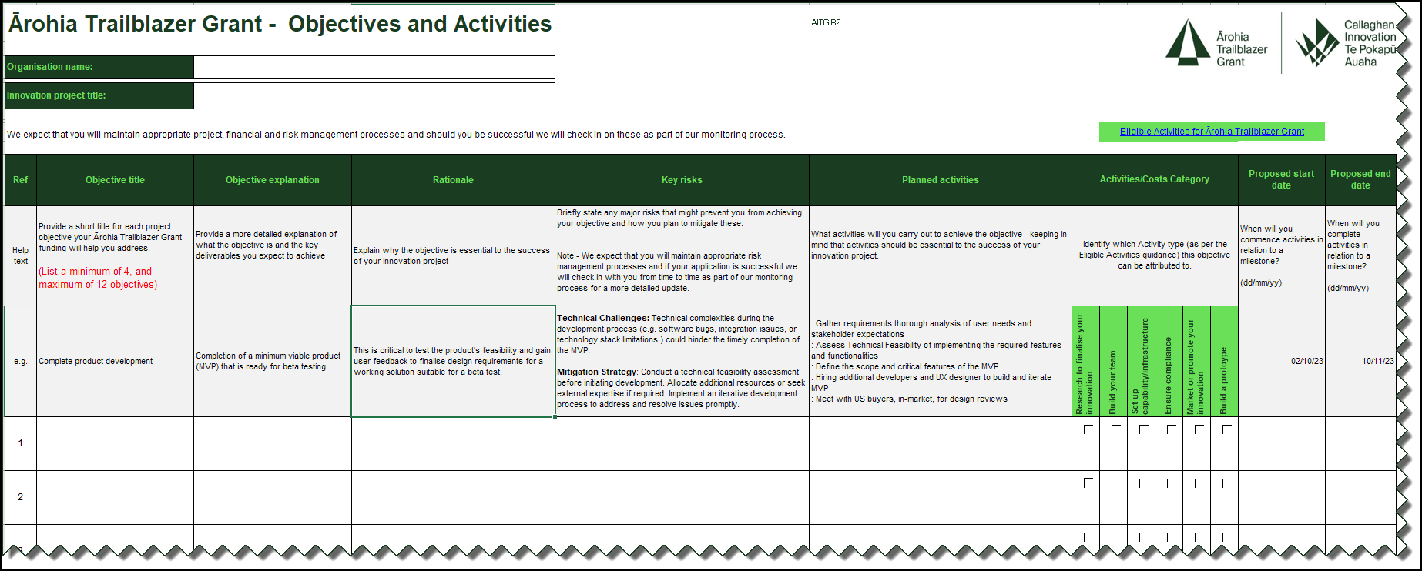

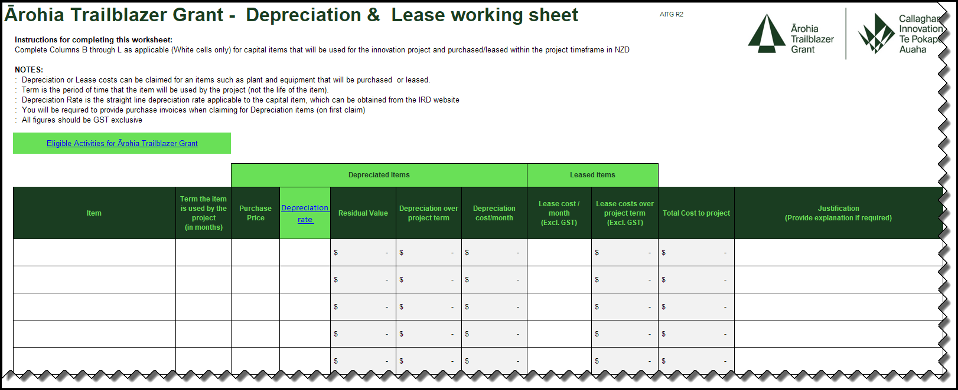
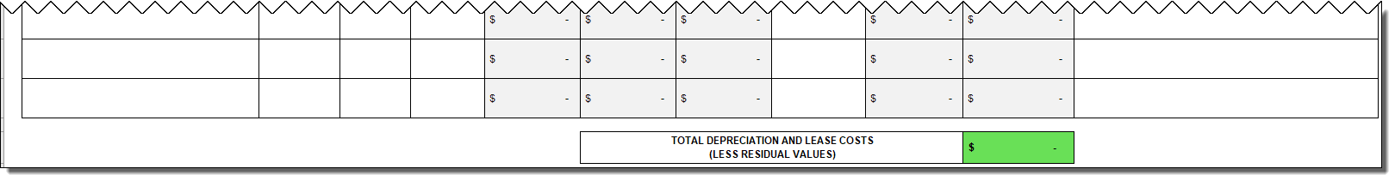
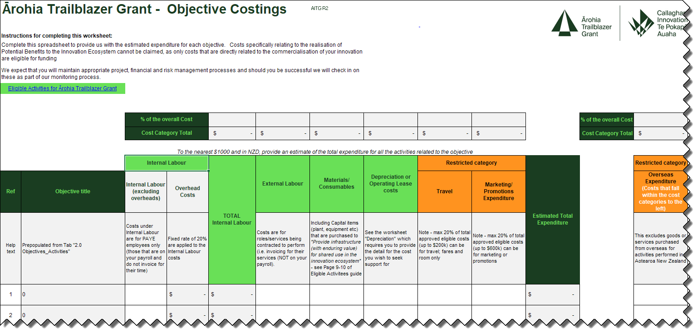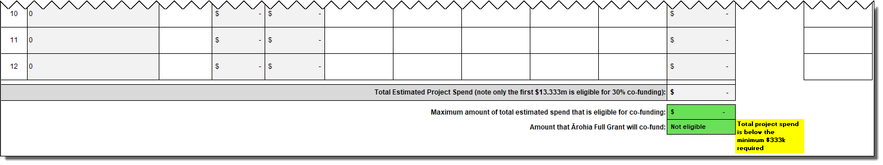

SECTION 6: FINancial information

6.1 Financial Information Table
Enter information for the last three financial years, including total R&D* spend and staffing levels (NZ$ excl. GST).
*Even though the Ārohia Trailblazer Grant does not support R&D activities, this is standard information we require from all grant applicants, so that we can understand the scale of R&D in your business and the impact our grant funding has on businesses.

Update these figures using information from your most recent financial statements.
If your business has been operating for less than three years, enter the information for each financial year since your business started operating.

Do not delete or overwrite any prior year data. Please ADD a new line for each relevant year as required.

Financial Year End | Total revenue: | Earnings before Interest and Taxation (EBIT): | Net profit before taxation: | Exports revenue: | Total R&D spend: | Total staff (FTE): | R&D staff (FTE):
Enter date here | Enter value | Enter value | Enter value | Enter value | Enter value | Enter value | Enter value
Enter date here | Enter value | Enter value | Enter value | Enter value | Enter value | Enter value | Enter value
Enter date here | Enter value | Enter value | Enter value | Enter value | Enter value | Enter value | Enter value
The table above requires three years of information to be entered, if you are not able to provide all of this information, provide comment below:

Enter text here

6.2 Financial Information & Uploads
6.2.1 Tell us about your ability to fund your share of the innovation activities.

Include in your answer, any capital raising activities, shareholder funding or loans and any other relevant information to enable us to assess your ability to fund the activities.

Upload any relevant documents such as letters of intent, investment terms sheet, expressions of interest etc. in the area provided below.

Enter text here
    - Upload the following information:

- Last two years’ Profit and Loss Statement and Balance Sheet
- Cashflow template covering the two-year grant period.
- Other relevant documents (e.g., letters of intent, term sheets, recent bank statements etc)

If you do not already have an Excel version of your cashflow forecast, complete the following template.
(This template is only available after you have created your application within the online portal (IMS)

Once you have selected your file, click SAVE at the bottom of the screen, and your document will be uploaded.
Enter text here

DECLARATION

This section is to provide you with the opportunity to read the declaration that you must agree to, upon submission of your Application.

Please ensure you have checked that all sections are complete, you have checked your work and you have uploaded the required information. Once submitted you will not be able to make any changes to this application. We also recommend you use the spell check function across all your text boxes as it is not automatic. This can be accessed at the top of each text box.

You agree that by submitting this application to Callaghan Innovation, you declare and acknowledge the following:

Disclosure of information
- You consent to us disclosing information (including commercially sensitive and confidential information) to our employees and/or our professional advisors, auditors, service providers and independent contractors who have a specific need to have access to the information in the course of their work for us. For example, we may use external assessors to assist us with assessing applications and our Grant Evaluation Panel will have access to your application. In each case, the information will be disclosed with a legal obligation to keep that information confidential and only used for the purpose for which it is disclosed.
- You consent to the release of information received and generated by Callaghan Innovation in relation to this application in accordance with Callaghan Innovation’s external reporting requirements or if required by law, including in accordance with the requirements of the Official Information Act 1982 or the Privacy Act 2020
- You consent to the disclosure of this application and all information relating to this application, to New Zealand Trade and Enterprise, Ministry of Business, Innovation and Employment, Callaghan Innovation, Inland Revenue, StatsNZ and other government departments or agencies for the purpose of achieving wider government policy objectives.
- We will take reasonable steps to protect your personal, confidential and/or commercially sensitive information, including where necessary, de-identifying and/or redacting information that is not necessary to share to meet our obligations.

Authority to release information
- You declare that you are authorised to submit the application on behalf of the applicant.

Accuracy of information provided
- You declare that the information in this application is true and correct.

Awareness of eligibility declarations
- You declare that you are fully aware of the eligibility declarations in Section 2 and 3 of this application.

To submit your application, click the 'Submit to IMS' button in the 'Print and submit' section below.
Note: The application must be submitted by your organisation’s ‘super user’ (If you do not hold this role, you will not see the “Submit to IMS” button.)

